Welcome!
Date
Name
Spouse
Address
City
State Zip _________
Email

Please Contact By
❑ Card  Phone  Visit

Telephone Best Time to Call
Home ______________
Work ______________

Guest: First Time Second Time
Are you a church member: yes no
Church
City, State

Circle Appropriate Age/Grade Group(s)
Preschool: Ages: B-1 2-3 4-5
Children: Grades: K 1 2 3 4 5 6
Youth: Grades: 7 8 9 10 11 12
Adults: Ages:18-29 30s 40s 50s 60s+

How did you learn about our church?
Newspaper Friend Yellow Pages Mail
Other

I am a guest of:

New in the Community? Yes No
Names & ages of children at home

Weekly Service & Activity Schedule

September 20, 2015

9:45 a.m. Sunday School
11:00 a.m. Worship Service
4:30 p.m. Operation Christmas Child Box Packing
6:00 p.m. Evening Worship

Week of September20, 2015
Wednesday 7:00 pm Adult Bible Study
Thursday 10:00 am Adult Fellowship

Upcoming Events
September
23….See You at the Pole (Global Week of Student Prayer)
24…………………………………………..…Adult Fellowship
October
4…………………………Bridal Shower for Rachel Edwards
8…………………………………………..…..Adult Fellowship
11…………………………………….………Business Meeting



Join us today at 4:30
Give a child the blessing of a gift in a shoebox….and guaranteed, you will receive a blessing as well!

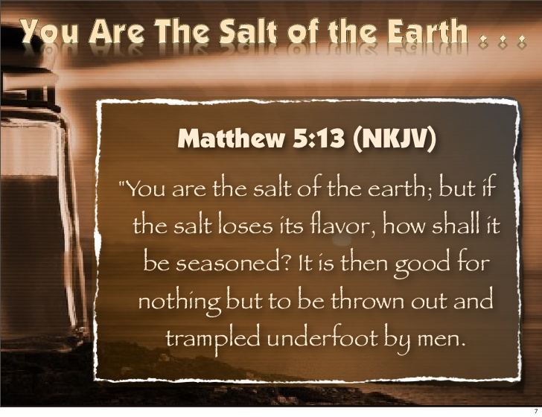

Knobbs Springs Baptist Church

September 20, 2015

Church Information:

KnobbsSpringsBC.com KnobbsSpringsBaptist@gmail.com

1662 CR 305, McDade, Texas 78650 512-273-2743

David Atwood, Pastor Cell 512-470-5098
Home 512-856-2819
Patti Radford, Office Manager Cell 512-968-7821

